
xEV Plug & Charge Experience
PRD
Product Requirements Document
Electric Vehicle Connected Services
(Feature Bundle 5)

Version 4.0

4/12/2021

Table of Contents

1. Executive Summary 11
1.1 Purpose of this document 11
1.2 Current charging experience 11
1.3 Future charging experience 11
1.4 Scope of this Document 12
1.5 Business objectives 12
1.6 Assumptions 12
1.7 Constraints 13
1.8 Dependencies 13
2. Product Detail 15
2.1 Feature Description 15
2.2 Integration Points 15
2.2.1 Monetization Platform 15
2.2.2 FordPay 15
2.2.3 Ford Network Charging Stations/Mobility Operator 16
2.2.4 Navigation Cloud 16
3. Architecture Overview 16
3.1 Architecture Design 16
3.2 Actors 17
4. High Level Journey 18
5. Vehicle Manufacturing 19
6. Onboarding 20
6.1 Registration 21
6.2 Add Vehicle to FordPass Account 21
6.3 Payment 21
6.3.1 Possible Subscription Options 21
6.4 Access to the Charging Network 21
6.5 Feature Introduction 21
6.6 Customer Connectivity Settings (CCS) 21
7. V2G Root Certificate 23
8. Turning on Plug & Charge 23
8.1 Feature Activation 23
8.2 Contract Certificate Installation 23
8.2.1 Contract Data Package Delivery 24
8.2.2 Storing Setting in the Cloud 25
8.2.3 Plug & Charge on Confirmation 25
9. Low Charge Alert/Searching for a Station 25
10. Warm Welcome/Geofencing 26
10.1 Receiving Warm Welcome 26
10.2 Nav HMI Display 27
10.3 Connectivity to Nav Cloud 27
10.3.1 Charging Station Close to Home 27
10.3.2 Far from Vehicle Home 27
11. Plug In & Charge Begin 27
11.1 Charge Begin is Successful 28
11.1.1 Vehicle Trust of EVSE 28
11.1.2 Sending PaymentDetailsREQ Message 29
11.1.3 EVSE Authenticates the Contract Certificate 29
11.1.4 Mobility Operator Authorizes eMAID 29
11.1.5 Payment 29
11.1.6 User Notification 30
11.2 Sending Charge Station Information to the Cloud 30
11.3 Charge Begin is Unsuccessful 30
11.4 Plug & Charge Off 32
12. Charging in Progress 32
12.1 Status 32
12.1.1 FordPass Status 32
12.1.2 In-Vehicle Status 32
13. Charging Complete 32
13.1 In-Vehicle 32
13.2 FordPass Notification 33
13.3 Trip & Charge Log Updated 33
14. Disabling Plug & Charge 33
15. Re-Enabling Plug & Charge 34
16. Managing Expired Contract Certificates 35
16.1 Success 35
16.2 Failure 35
17. Master Reset/‘Brand’ Connect Reset/Last User Removal 36
18. OBCC Swap 37
19. Subscription Rules 37
20. RFID Card – EU Only 38
21. Charging Ecosystem 38
22. Choosing Contract Certificates Based on Domain component Data Field in EVSE Leaf Certificates (SECC Certificate) 39
23. V2G Certificate Delivery Upon OBCC Provisioned at EOL 39
24. V2G Certificate Delivery Upon FordPass app Authorization 40
25. V2G Certificates Retry Mechanism 40
26. EOL Config for Each Vehicle Life Cycle Modes 40
27. Report all the Installed Certificates Status to CVBOP 41
28. Fleet Requirements 41
29. Appendix 42
29.1 Additional Certificate Handling Details 43
29.1.1 Certificate Handling 43
29.1.2 Certificate Handling Actors 43
29.1.3 Charge Point Operator (CPO) 43
29.1.4 Mobility Operator (MO) 44
29.1.5 Role of External IT backend Operation 45
29.1.6 Authentication 45
29.1.7 Authorization 45
29.2 Provisioning Certificate Procedure 45

Change Control
Table A Version History
Version | Author | Description | Sections Affected | Release Date
1.0 | Rutna Gadh & Sandeep Jujavarapu | Initial version of PnC PRD | All | 5/18/2018
1.1 | Rutna Gadh & Sandeep Jujavarapu | Updated architecture diagram | 3.1 | 5/25/2018
1.2 | Rutna Gadh | Changed diagrams to be in swim lane format |  | 5/28/2018
1.3 | Rutna Gadh | Moved background cert information to Appendix | 19,20 | 6/1/2018
1.4 | Rutna Gadh | Verified Subscription options and payment-related charging errors | 6.3.1, 10.3 | 6/4/2018
1.5 | Sandeep Jujavarapu | Updated numbering | All | 6/6/2018
1.6 | Sandeep Jujavarapu | Updated numbering | All | 6/8/2018
1.7 | Sandeep Jujavarapu | Updated numbering | All | 6/10/2018
1.8 | Rutna Gadh | Updates post PRD review on 6/14 |  | 6/14/2018
1.9 | Rutna Gadh | Added Master Reset, MMOTA, Disabling and Re-Enabling PnC sections | 13-17 | 6/16/2018
2.0 | Rutna Gadh | Updated the following:  Section 3.1  - Corrected architecture diagram  Section 5  - Updated OEM Certificate Installation Process diagram  Section 9  - Moved Feature Introduction and added details on WHEN feature intro is displayed  Section 10.1  - Edited “Charging Event” diagram  Section 14  - Added Re-Enabling Plug & Charge section and included diagram  Section 15  - Added Managing Expired Contract Certificates section, with details TBD  Section 16  - Added Master Reset section, requirements 50% complete | See updates | 6/20/2018
2.1 | Sandeep, Rutna | Highlighted requirements that involve other team specifications  Updated DCGM to OBCC (same module, new name)  Section 5  - Added details based on EPE updates  Section 6.5  - Updated CCS settings based on recent workshops  Section 6.6  - Updated details based on EPE notes  - Added details about V2G root certificates  Section 8  - Updated overall rule around when Warm Welcome is displayed  Section 8.2  - Changed “charger type” to “charging speed”  Section 10.3  - Changed credit/debit card expiration issue to general credit/debit card issue  - Added error message when EVSE has a problem  Section 18  - Added OBCC Swap section |  | 7/6/2018
2.2 | Sandeep, Rutna | Section 3.1  - Updated architecture diagram  Section 3.2  - BCCM description  - OBCC description  - Mobility Operator description  - CPO description  Section 5  - Updated Figure 5 with IVSS responsibilities  Section 6.6.1  - Added new section “Feature Activation”  Section 10  - Clarified that charging preauth needs to be completed before charging begins  Section 10.2  - GPS location not delivered from OBCC  Section 10.3  - Updated charge Begin unsuccessful sample messages from Team Edison  Section 11.1.2  - In-vehicle status when charging in progress is no longer in the scope of this document; will be determined and implemented under another feature |  | 7/13/2018
2.3 | Sandeep, Rutna | Internal/formatting changes |  | 7/17/2018
2.4 | Sandeep, Rutna | Section 6.6.2  - Updated diagram with FENIX responsibilities |  | 7/20/2018
2.5 | Sandeep, Rutna | Section 1.6  - Added assumption  Section 6  - OTA  Section 6.5  - Removed Feature Introduction from vehicle – only displayed in FP  Section 6.6  - CCS – user can use PnC without location services enabled  Section 6.7.5  - Added that VIN to ESN mapping would stored by the cloud  Section 9.3  - Updated error messages table  Section 11.1, 11.2  - Added “Total distance added” in receipt notification  Section 15  - Master Reset recovery not in scope for the feature  - Added Master Reset diagram initiated by cloud
2.6 | Sandeep, Rutna | Section 6.7.2  - Updated contract cert delivery diagrams  Section 9.1.1  - Included importance of vehicle time signals  Section 15  - Updated master reset diagrams |  | 8/17
2.7 | Sandeep, Rutna | Internal changes |  | 9/7
2.8 | Sandeep, Rutna | Section 6.7.2  - Contract cert diagram: replaced “FENIX” with “Cloud”  Section 9.2  - Cloud to receive EVSE ID upon plug in to any digital station  Section 9.3  - Sample notification text based on updates from copywriters  Section 15  - Removed CAN signal names from flow diagram to remove redundancy with PSD |  | 9/11
2.9 | Sandeep, Rutna | Section 6.6  - Added new column for new CCS setting  Section 6.7  - Added priority of payload  Section 9.2  - Added reasoning behind EVSE ID collection for legal purposes
3.0 | Sandeep, Rutna | Sections highlighted in green |  | 10/23/18
3.1 | Rutna | Section 1.1  - Edited feature definition in regions  Section 1.3  - Added link for basic experience  Section 6.6  - Added requirement to disable PnC when CCS are turned off  Section 6.7.2  - Added link to OBCC Certificate Management spec  - Edited diagram to read “Paak FI” instead of “PnC FI”  Section 6.7.6  - Added feature status in the center stack  Section 8  - Removed Warm Welcome requirement  Section 9  - Updated max time for PnC start to 20 seconds  Section 9.1  - Updated diagram  - Added details on “PnC Authorization in progress”  Section 9.2  - Added TLS and station type to be communicated to the cloud  Section 15  - Updated based on OBCC/BCCM changes |  | 12/17/2018
3.2 | Rutna | Section 2.2.3  - Updated CMS description  Section 3.1  - Updated architecture diagram  Section 3.2  - Updated actors section to replace TMC with VSDN  Section 6.6  - Updated requirement such that certificates are deleted when CCS is disabled  Section 6.7  - Added which users can toggle the feature in FordPass  Section 9.3  - Added which users will receive the failure notifications  Section 11.2  - Added which users will receive “receipt” in FordPass  Section 12  - Added which users will receive notifications in FordPass  Section 13  - Added which users will receive notifications in FordPass  Section 15  - Updated reset flows to reflect changes to OBCC/BCCM  - Removed reference to “feature reset” as there is no feature reset for PnC |  | 3/8/2019
3.3 | Rutna | - Updated description of how enrollments are triggered for the feature  - When CCS are disabled, the feature will be disabled, but certificates will not be deleted  - Added new section to explain when the user will be un-enrolled from the feature | 6.4, 6.6, 18 | 4/11/2019
3.4 | Rutna | - Changed format of and updated CCS table | 6.5 | 5/6/2019
3.5 | sjujavar | - Updated In-Vehicle HMI Error notifications  - Updated HMI notification Rules  - Added Charging Eco-system section and sequence diagram | 9.3, 9.16, 19 | 6/13/2019
3.6 | sjujavar | - Updated Contract Certificates delivery flow diagram  - Updated Vehicle Manufacturing requirements  - Added new section for Choosing Contract Certificates based on Domain component data field in EVSE Leaf certificates (SECC Certificate) | 6.7.2, 5, 20, | 8/23/2019
3.7 | sjujavar | - Removed In-Vehicle HMI Pop-ups  - Updated CCS table  - V2G Certificate Delivery upon OBCC Provisioned  - Removed FordPass Payment notifications  - Added FordPass PnC feature status edge cases | 6.6, 21,9.3, 6.8.3 | 5/10/2020
3.9 | sjujavar | - V2G Certificate Delivery Upon FordPass app Authorization  - EOL Config for Each Vehicle Life Cycle Modes  - Report all the Installed Certificates Status to CVBOP  - Fleet Requirements  - V2G Certificates Retry Mechanism | 23, 24, 25, 26 | 3/1/2021

1. Executive Summary

Purpose of this document
The purpose of this document is to lay out requirements gathered for the new Plug & Charge feature. The Plug & Charge feature will change the EV charging experience at a subset of public charging stations by allowing customers to plug in and for charging to start immediately. The Plug & Charge feature will be available to all new Ford and Lincoln BEVs starting in MY 2021 in North America and the EU. The feature will function the same in both regions.

Current charging experience
Currently, for users to charge their electric vehicle at a public charge station, they must determine the charge station operator and understand the process required to charge with that particular operator. There is a range of charging methods, with some operators allowing direct credit card entry into the station while others require the user to download their app or have their RFID card.
Regardless of the charge station operator, EV drivers do not have a seamless experience when it comes to public charging.

Future charging experience
Plug & Charge aims to create a streamlined user experience when charging at P&C enabled charge stations. The goal for Plug & Charge is to take drivers out of external applications and increase FordPass traffic. Along with Plug & Charge technical implementation, Ford is working on creating a network of charging stations with whom Ford can collaborate to ensure this seamless charging experience.
Plug & Charge is one of 5 new EV features that aim to make Ford/Lincoln EVs more competitive in the market. These features will be dependent on one another to some extent. The other features are:
- Locate/Pay
- Smart Charging
- Trip Planner
- Cloud Based POIs

There will be 3 possible charging experiences are implemented for Plug and Charge feature, with the Elite being the most seamless one. Only the Elite experience is included in the scope of this document. The three experiences are listed below:
- Elite experience
  - When user plugs into ISO 15118-2 charge station that is in Ford’s network
- Select Experience – not in scope of this document
  - When user plugs into non-ISO charge station that is in Ford’s network
  - Utilize QR code reader with charge station
  - This experience is in scope of the Locate and Pay feature
- Basic Experience – not in scope of this document
  - When user plugs into any charge station outside of Ford’s network of stations
  - Utilize external app or payment process specified by given charge station
  - This experience is found in the EV Features FB5 PRD.
EV Experience | Elite | Select | Basic/Current
Details | User plugs in and charging starts immediately | User utilizes QR code reader in FordPass and then uses FP wallet | Credit card entry into charging station or app download followed by payment via app

Scope of this Document
The scope of this document is the Plug & Charge experience, which, as stated above, is for customers charging at ISO 15118-2 charging stations within Ford’s network of stations.

Business objectives
In the transition from the current charging experience to the Plug & Charge feature, the following business objectives should be achieved:
- Encourage MY 2021 BEV owners to utilize Plug & Charge feature to increase Ford in-network station usage and increase FordPass and FordPay adoption
- Support ISO 15118-2 compliant charging stations
- Support MVP build milestone for CX727 in North America and the EU
- Include an OBCC module in all MY 2021 BEVs such that the vehicle can communicate with the charging stations
- Support subscription based and payment-based plans to allow user to select payment options most suited to their needs

Assumptions
No. | Description
A1 | To utilize the Plug & Charge feature, the user has a FordPass/LincolnWay account and has downloaded the app
A2 | EV Customers will use FordPass and LincolnWay for their connected experience
A3 | TCU is authorized
A4 | Designs and Concepts of UI/UX shown in PRD are not finalized content. UI/UX team to define the full experience.
A5 | The FordPass team will determine how the experience will differ on the web and the mobile app. For the purpose of this document, any reference to “FordPass” is any of the defined FordPass channels.
A6 | The user experience for this feature will be consistent across FordPass, HMI and web
A7 | In Vehicle notifications and charging status channel will be determined by in vehicle teams; for the purposes of this document, “in vehicle” refers to either cluster or the SYNC HMI.
A8 | The “Charging In Progress” in-vehicle experience will be defined outside of Plug & Charge
A9 | One account is authorized to pay for charging per VIN.

Constraints
No. | Description
C1 | Feature availability is limited for access to registered owners/users in supported regions (North America and Europe)
C2 | Feature experience is dependent on the chosen mobility operator/charge station aggregator for each region

Dependencies
No. | Description
D1 | BEV must have an OBCC and TCU equipped and functioning in a supported wireless LTE coverage area to provide the requested vehicle data.
D2 | Mobile app availability (for download) will depend on mobile application store (Apple Store and Google Play).
D3 | Detailed business rules and requirements relating to the user flows in this PRD are captured in the CVPP PSD as well as individual team requirements; the requirements necessary from each team are detailed below.
D4 | The full Plug & Charge experience is dependent on other features such as Low Charge Alert and Locate/Reserve/Pay
D5 | The Plug & Charge experience will be in part determined by the Smart Charging experience
D6 | Plug & Charge feature is dependent on Ford having partnerships with charging stations, as well as choosing a mobility operator and certificate authority
Below is a list of teams that need to send detailed specifications necessary for Plug & Charge feature implementation. These teams have been notified of the action required. The full Stakeholder List can be found here.

Team | Spec | Owner
SYNC/ECG | SPSS | Robert Paquette
HMI | HMI Flow | Mohammad Kalash
CCS |  | Micha Kahlen
EPE | OBCC IFS | Yuan Zhang
IVSS | Contract Cert one-pager | Dmitriy Ansolis
Payment, Subscription |  | Meghan Giammarusti
FordPass | User Journey  Service Blueprint  VML Designs | Brian Nash
Cyber Security - Onboard specs | PnC Cyber Security specification | Cameron Smyth
Cyber Security - Offboard specs | PnC Cyber Security specification | Chuck Schneider
Supplier Feed | OBCC Supplier Feed | Karthikeya
Provisioning | ECG, TCU, SYNC, peripheral SPSS | Derek Porter
Master Reset | Master Reset PRD/ PSD/SPSS | Pankaj Borgaonkar
Cloud | BIM/BOV | Prasad Pratapa  Sneha/Yona/Kavita/Greg

Product Detail
The diagram below shows the high-level entities involved in the Plug & Charge experience.
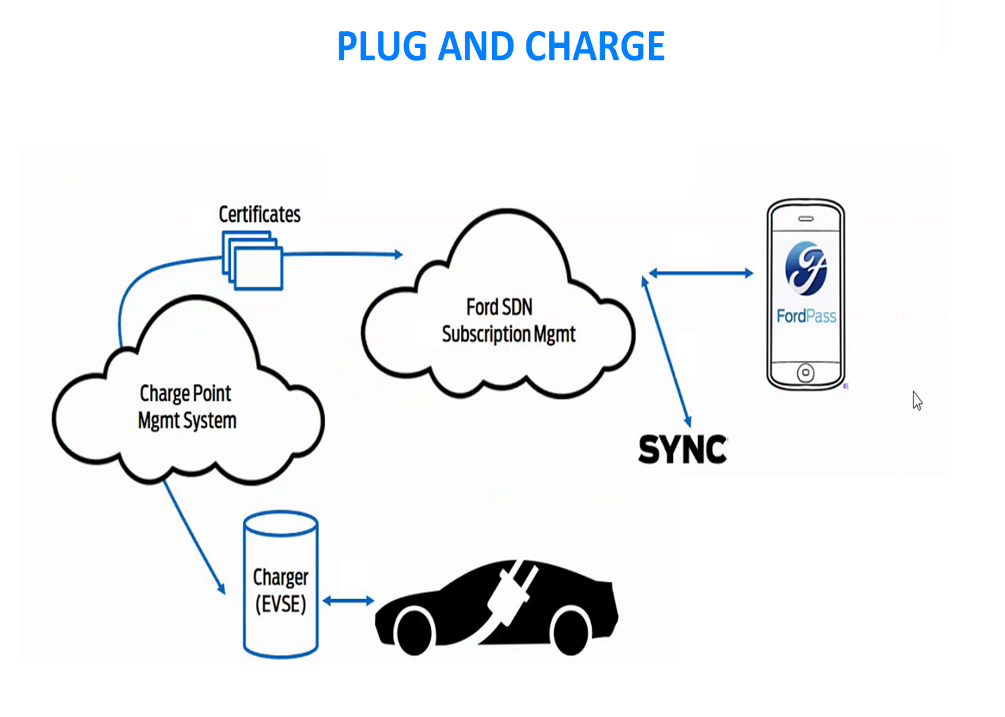
Figure 2: High Level Plug and Charge Diagram

Feature Description
Plug and Charge provides an effortless charging experience for the owner of Ford BEV when a user plugs their vehicle at charging station that support PnC Functionality i.e. ISO 15118.2 and charge station in Ford network (cf. Ford Network Charging Stations below).
When the user plugs in:
- A secure handshake takes place between the vehicle and the charge station after which Certificates transfer begins. This allows for seamless vehicle identification and billing to take place behind the scenes.
- Charging will begin automatically, and the user will able to see this on the app and in-vehicle
The onboard security specifications are documented in CyberSecurity_PnC_Onboardspecs.

Integration Points

Monetization Platform
The monetization platform under Subscription Management will provide the subscription business capabilities including provision systems, payment, and billing and user channels. The subscription capabilities are adaptable to charging-specific needs.

FordPay
FordPay will provide the wallet and backend payment systems used to verify payment input in the FordPass app.

Ford Network Charging Stations/Mobility Operator
The Ford backend will contain a new system, called Electric Vehicle Specific Services (EVSS) to integrate the Ford cloud applications with the various mobility operators. Each mobility operator has partnerships with one or more charge station providers, which will allow Ford to have a “network” of charging stations.

Navigation Cloud
The Navigation cloud will provide GPS information to the in-vehicle navigation system.

Architecture Overview
As a part of the Plug & Charge feature, there will be many changes in-vehicle and to the Cloud architecture. This section details which parts of the architecture will require these changes.

Architecture Design
Below is a detailed view of the Plug & Charge architecture; the main pieces are the Cloud, the Vehicle, the Charging station and the Certificate handling authorities.

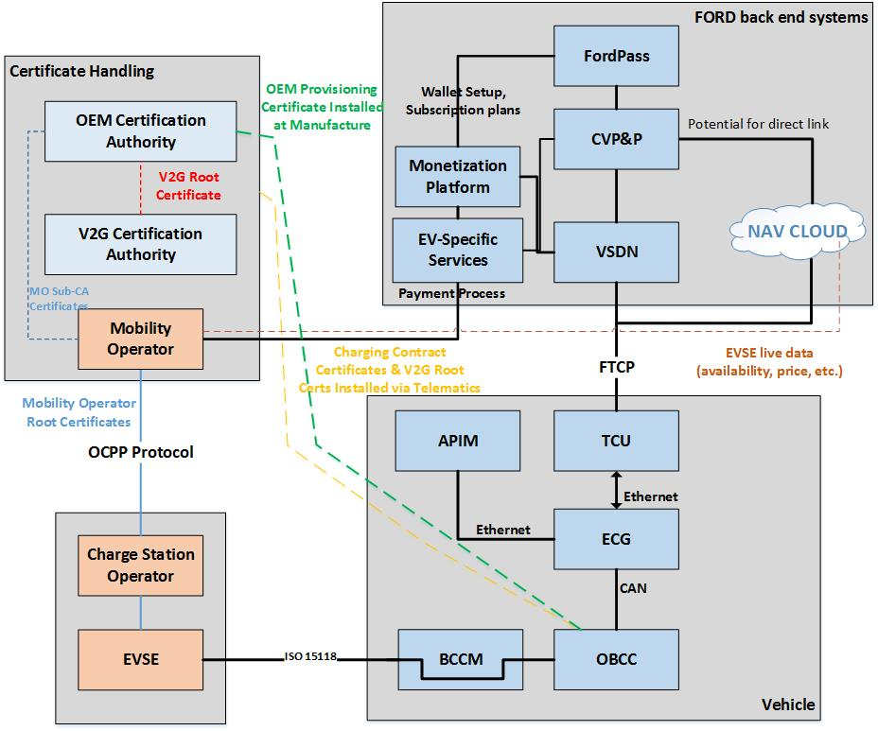
Figure 3: Detailed Architecture Diagram

Actors
Below is a list of actors in the system, as shown above, and a description of their roles. More details around how these actors interact with each other will be described in the user journey.
Actor | Team Responsible | Description
4G TCU | TCU team | Telematics Control Unit operating in Azure SDN. This unit supports 4G wireless technologies and will substitute technologies deployed in previous TCU versions.
EVSE | EPE | The Electric Vehicle and Supply Equipment is the device the user plugs the EV into and meters electricity to the vehicle.
BCCM | EPE | The Battery Charge Control Module regulates AC power for basic charging of the main traction battery on PHEVs and BEVs. The module also initially determines if basic or digital charging communication will be used, based on signals received from the charging station at time of plug-in.
OBCC (industry name EVCC) | EPE | The Off-Board Charge Control module is responsible for communication with AC or High Power DC charging stations using the ISO 15118-2 standard protocol.
IPC | Cluster team | The Instrumental Panel Cluster – Displays charging information, battery percentage and other charging related details
ECG | ECG team | The Enhanced Central Gateway an Ethernet enabled component with excess computing capability to house and /or bridge next generation technology.
EV Specific Services | Team Edison | Integration layer between the mobility operator and Ford backend systems
HPCM | EPE | Hybrid Powertrain Control Module – in vehicle module that holds Departure Times and Charge Settings
VSDN | Cloud team | The Vehicle Service Delivery Network facilitates data communications between TCU/ECG and Ford off-board backend systems collectively called Connected Vehicle Platform and Products (CVP&P).
NAV CLOUD | Nav team | The Navigation Cloud is used to get EVSE live data, availability and price etc.
Mobility Operator(s)/Charge Management System (CMS)  New Motion (EU), Greenlots (NA), Electrify America (NA) | Team Edison | Business entity with which Ford has a contractual agreement to authorize payment for charging services when requested by Charge Point Operators.
Monetization Platform | Monetization Platform team | Communicates with the EV Specific Services and the SDN
Charge Point Operator – Ionity (EU), Charge Point (NA), EVGo (NA), EVConnect (NA)……. | Team Edison | Companies that operate and maintain charging sites, charging stations (EVSEs), and purchase energy form Utility or 3rd Party Energy Service Providers
Ford Pass | FordPass team | Mobile app used to present information, configure and command Ford Vehicles.

High Level Journey
The next few sections will detail the Plug & Charge user journey. The steps in this journey are displayed in the diagram below.
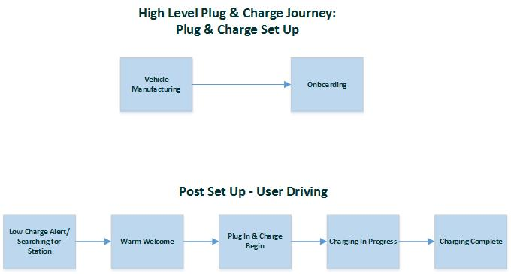
Figure 4: High Level Plug & Charge Journey

Vehicle Manufacturing
During vehicle manufacturing, installation of OEM Provisioning Certificate and corresponding OEM Provisioning Private Key is done to establish the digital identity of a vehicle. The OEM Provisioning Certificates are created by Ford and installed in the Off-Board Charge Control module (OBCC) by the Supplier. The OEM Provisioning Certificate and associated Provisioning Private Key are unique for each vehicle.
The diagram below summarizes steps necessary in order for Ford and the OBCC module supplier to install the OEM Provisioning Certificates in the vehicle.
- Ford IVSS creates the OBCC provisioning package, which includes the following:
- Ford Electronic Serial Number (FESN): unique Ford module identifier
- OEM Provisioning Certificate
- OEM Provisioning Private Key
- OBCC Module SyncP Key: unique key per module for Contract Certificate installation via telematics
- Master SyncP Key: protects for future key rotation (including Contract Certificate private key deletion)
- Ford encrypts each OBCC provisioning package with a unique symmetric key for each FESN; symmetric keys are then encrypted with a Supplier Public Key
- The encrypted OBCC provisioning packages and FESN symmetric keys are sent to the OBCC Supplier.
- The Supplier decrypts FESN symmetric keys using their corresponding Supplier Private Key.
- Individual OBCC provisioning packages are decrypted using the FESN-specific symmetric key.
- The Supplier flashes the OEM Provisioning Certificate in non-volatile RAM (NVR) of the OBCC module.
- The Supplier flashes the OEM Provisioning Private Key in the Hardware Security Module (HSM) of the OBCC module and Provisioned OBCC modules are shipped back to Ford for testing and verification.
- At the time of manufacturing, an OBCC module is installed in a vehicle and a correlation is made between the OBCC FESN and the vehicle VIN#.
- Ford stores the OEM Provisioning Certificate and Provisioning Private Key, now correlated by vehicle VIN#, in the GIVIS system
- In a future step, the OEM Provisioning Certificate and Provisioning Private Key can be retrieved in order to create a Charging Contract Certificate when the customer activates the Plug and Charge feature.
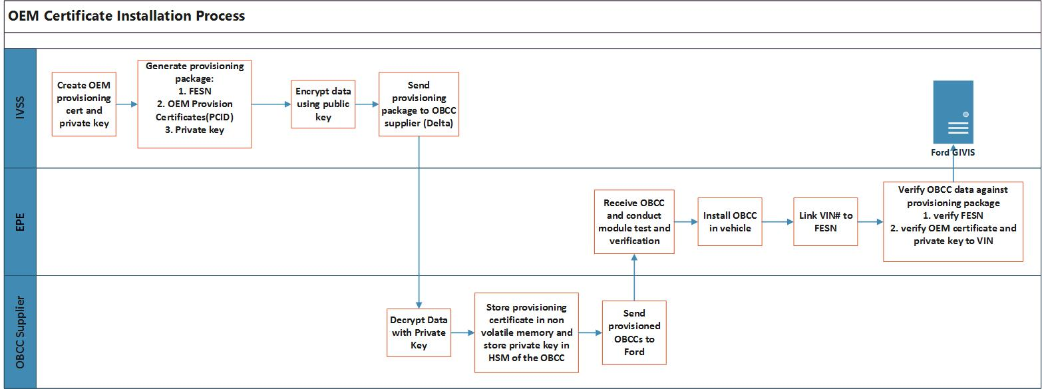
Figure 5: OEM Provisioning Cert Correlated withVIN at time of Manufacture

Supplier feed specs are detailed by the Supplier Feed FO in A51o-FNV 2.0 - OBCC_Supplier_Feed.
Detailed OEM provisioning cert process specs are detailed by IVSS in the OBCC OEM Provisioning Spec.
Detailed OBCC provisioning specs will are detailed by the Supplier Feed FO in the Peripheral Module Provisioning SPSS.

Onboarding
This section details the steps that must be completed in the onboarding process for Plug & Charge to be used. The diagram below shows these steps.

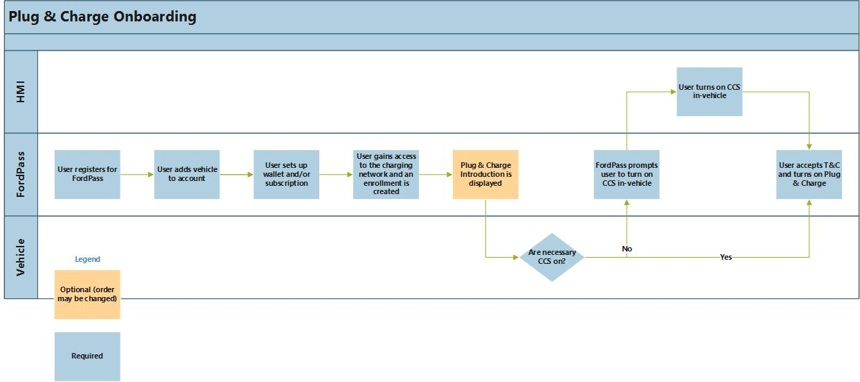
Figure 6: Plug & Charge Onboarding Process

Registration
User needs to be registered with the FordPass app.

Add Vehicle to FordPass Account
In order to utilize the Plug & Charge feature, the user must download the FordPass app and complete the authorization process.

Payment
In order to utilize the Plug & Charge feature, the wallet must be set up. This involves entering valid credit card information. The wallet set up is required to use Plug & Charge, while the selection of a subscription is optional. The wallet can only be set up via FordPass.

Possible Subscription Options
The possible subscription options will be contained the Monetization Platform requirements.

Access to the Charging Network
After the user gains access to the charging network, an “enrollment” is created in the backend. The enrollment indicates that the vehicle has the capability to user Plug & Charge. However, the user will still need to enable the toggle via FordPass to gain access to the feature.

Feature Introduction
The user will have the ability to watch an introduction to Plug & Charge through FordPass.The FordPass/VML team will provide detailed specifications on how and when the Feature Intro will be displayed in the FordPass.

Customer Connectivity Settings (CCS)
The CCS feature provides the ability for a user to opt-in/opt-out from connectivity settings within the vehicle. This will allow the user to enter a customized connectivity mode such as privacy mode or to prevent data sharing such as GPS location. Customer connectivity settings (CCS) is enabled or disabled from the vehicle HMI. The Plug & Charge experience will be impacted based on CCS settings as shown below.

CCS Impact on Requirements | Vehicle Connectivity Disabled | Vehicle Data Disabled | Location Sharing Disabled | Driving Characteristics Disabled
PnC toggle on available | No – PnC ECG app is turned off in vehicle | No – PnC ECG app is turned off in vehicle | No – PnC ECG app is turned off in vehicle | Yes
PnC toggle off available | N/A (PnC is off already) | N/A (PnC is off already) | N/A (PnC is off already) | Yes
Charging begins when using PnC after plugged in (assuming no other errors) | No – PnC ECG app is turned off in vehicle | No – PnC ECG app is turned off in vehicle | No – PnC ECG app is turned off in vehicle | Yes
Charging in progress status shown in vehicle/app | Follows overall charging approach | Follows overall charging approach | Follows overall charging approach | Follows overall charging approach
Vehicle data available in Trip & Charge log | No – PnC ECG app is turned off in vehicle | No – PnC ECG app is turned off in vehicle | No – PnC ECG app is turned off in vehicle | Partial availability – total distance added will not be available
Ability for contract certs to be replaced after expiration | No – PnC ECG app is turned off in vehicle | No – PnC ECG app is turned off in vehicle | No – PnC ECG app is turned off in vehicle | Yes
Notifications
Plug & Charge setup, re-enable or disable notifications in app/vehicle | No – PnC ECG app is turned off in vehicle | No – PnC ECG app is turned off in vehicle | No – PnC ECG app is turned off in vehicle | Yes
Any payment related error shown in vehicle | No – PnC ECG app is turned off in vehicle | No – PnC ECG app is turned off in vehicle | No – PnC ECG app is turned off in vehicle | Yes
EVSE or vehicle failure in authorization process (e.g. certificate rejected by EVSE) shown in app/vehicle | No – PnC ECG app is turned off in vehicle | No – PnC ECG app is turned off in vehicle | No – PnC ECG app is turned off in vehicle | Yes
Charge event summary (cost + vehicle data) shown in vehicle | No – PnC ECG app is turned off in vehicle | No – PnC ECG app is turned off in vehicle | No – PnC ECG app is turned off in vehicle | Partial availability – total distance added will not be available
“Charging Receipt” notification shown in app | Yes – doesn’t come from vehicle | Yes – doesn’t come from vehicle | No – PnC ECG app is turned off in vehicle | Yes
Issue with expired certificate removal and reinstall in app | No – PnC ECG app is turned off in vehicle | No – PnC ECG app is turned off in vehicle | No – PnC ECG app is turned off in vehicle | Yes

When the customer turns off any of the following customer connectivity settings in the vehicle HMI, Plug and Charge feature will be disabled in both vehicle and cloud (CVPODS).
- Vehicle Connectivity
- Vehicle Data
- Location Sharing
CCS and Cloud teams will provide detailed specifications on how CCS will function.

V2G Root Certificate
- V2G Root Certificates are issued by a Certificate Authority designated for a given global region. They are used as the basis for checking other derived PnC certificates to ensure they are genuine and trustworthy.
- In order to use the Plug and Charge feature, a complement of (2 – 10) V2G Root Certificates must be installed in the OBCC modules of vehicles operating in that a given global region.
- The vehicle OBCC module uses V2G Root Certificates to authenticate charging stations using the ISO 15118-2 standard protocol and establish a secure, encrypted communication session. Which complement of V2G Root Certificates are needed will be determined by the Charging Contract Certificates created and sent to the vehicle upon OBCC Provisioning/Modem Authorization/Toggle-ON user activation of the PnC feature.
- Using a mechanism similar to that used to install Charging Contract Certificates via the Telematics system, the compliment of V2G Root Certificates needed by the vehicle to operate in that given region.
- See OBCC_Certificate_Management from EPE for more details on how certificates are installed and managed in the OBCC.

Turning on Plug & Charge
- When all of the preconditions are met, the user will be able to enable Plug & Charge. When the user turns on the feature, contract certificates will be installed, one for each mobility operator that user can charge with.
- Upon Toggle-On Request from FordPass app, if CVPODS has V2G certificates active state, it shall not re-delivery the V2G certificate.
Only subscription holder will be able to toggle the feature on and off and all other authorized users will be able to see the status of the feature in PnC FordPass screen.

Feature Activation
The Customer activates Plug & Charge in FordPass and VIN# is sent from FordPass to the cloud.

Contract Certificate Installation
- Using the vehicle VIN#, Ford can retrieve the OEM Provisioning Certificate and corresponding OEM Provisioning Public Key installed in the OBCC module of the customer vehicle. Using these files, along with additional files supplied by the Ford Mobility Operator partner, Ford will create a Charging Contract Certificate and associated data files.
- Contract Certificates are unique for each mobility operator authorizing payment for charging station operators in various markets (e.g., EU and US).
- During the creation, the Cloud application would request IVSS to add priority to the package-based location (region). This priority could be utilized upon plug in if there are multiple mobility operators.

- A Contract Certificate Data Package is comprised of several data elements:
  - Module FESN (of the target OBCC)
  - Charging Contract Certificate
  - Charging Contract Private Key
  - Mobility Operator Sub-CA Certificate Chain
  - eMobility Account ID (EMAID)
- More details on the Contract Certificate Data Package can be found in OBCC_Certificate_Management.
- The eMAID, encoded as the Subject field of the Charging Contract Certificate, is sent to the charging station by the vehicle OBCC when starting a charging session. The eMAID is needed by the back-end billing and payment system of the Mobility Operator to identify and authorize payment on a valid Plug & Charge agreement.
- Details around the delivery of the root certificate from the mobility operator and the sending of the Emaid from EVSS to the Mobility Operator will be provided by Team Edison and EVSS. Details around the creating and packaging of contract certificate will be provided by IVSS, PAAK FI and EPE.

Contract Data Package Delivery
The Contract Certificate Data Package will be encrypted and signed using the OEM Provisioning Certificate SyncP Key installed in the vehicle OBCC module. Additionally, the Data Package will be signed using a separate Private Key provided by Ford IVSS.
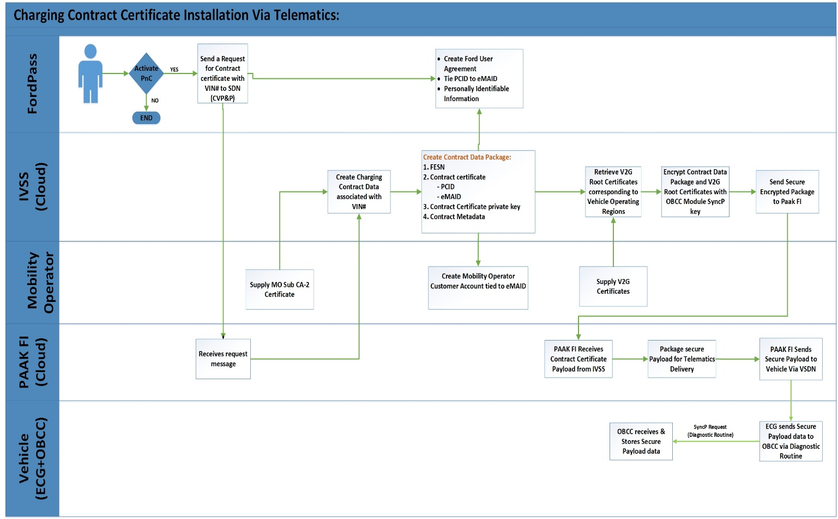
Figure 7: Contract Certificates delivery process

- The Contract Data Package is sent to the vehicle via the Ford Telematics system. The Data Package is received by the vehicle Telematics Control Unit (TCU), routed to the OBCC module through the Enhanced Communication Gateway (ECG) via CAN, and then authenticated by the OBCC module using a pre-installed IVSS Public Key.
- The OBCC then retrieves the OEM Provisioning Private Key stored in the Hardware Security Module (HSM), decrypts the Contract Data Package, and extracts various data elements. The OBCC module installs the Charging Contract Certificate in non-volatile RAM (NVR) and the Contract Private Key in the HSM.

Storing Setting in the Cloud
After the vehicle enables Plug & Charge, a confirmation is sent to the Cloud. The expiration date of the contract cert and the VIN to ESN mapping for the OBCC are also stored by the cloud. The PnC element stored in the cloud is now enabled.

Plug & Charge on Confirmation
Once Plug & Charge has successfully been enabled, a notification will be sent to the user via FordPass and in vehicle indicating that they are set to use PnC.
If for any reason there is a failure in enabling Plug & Charge, only a FordPass notification will be sent.
Due to the multiple CMS providers, PAAK FI shall deliver one Contract Certificate Package for each of the CMS Provider. So, FordPass will show PnC feature status as following on Edge cases below:
Green lots Certificate Package  (PAAK FI- determines) | Electrify America Certificate Package  (PAAK FI- determines) | Overall PnC status (PAAK FI- determines) | Message to Customer
Success | Failed  Or  Pending/Retry | Enabled  (Toggled On) | Required  Required
Failed  Or  Pending/Retry | Success | Enabled  (Toggled On) | Required  Required
Success | Success | Enabled  (Toggled On) | Not Required - Happy Path
Failure | Failure | Disabled  (Toggled Off) | Not Required - existing notification

Low Charge Alert/Searching for a Station
- The user can choose to navigate to a station by either receiving a Low Charge Alert and selecting a station or searching for and selecting a station.
- The Low Charge Alert is a feature outside of Plug & Charge that tells the user when the vehicle battery is below a certain percentage.
- When searching for a station, in addition to parameters defined by the Locate and Pay feature, the user will be able to view and filter on the following:
- In-network versus out of network
- Plug & Charge capable (Y/N)

Warm Welcome/Geofencing
- A Warm Welcome occurs when the driver navigates to a charging station using the in-vehicle Nav HMI.
- When the user gets close to the station, the Nav HMI will guide the user to charge by displaying useful information such as how much it will cost to charge and what stations are available. This feature will be an enhancement to the existing welcome feature Nav currently offers.
- The flowchart below displays the process of receiving a Warm Welcome when approaching a charge station.
Figure 7: How User Can Receive Warm Welcome

The Nav team will provide more detailed specifications on the Warm Welcome functionality.

Receiving Warm Welcome
When the user is within a predefined distance of the station, they will be prompted with the Warm Welcome. A Warm Welcome will be received regardless of whether the station type is Plug & Charge capable. The user will receive a warm welcome when navigating to a station. If the user is not using in-vehicle navigation to get to a station, he/she will not see the warm welcome screen.
When the user is within the defined distance from the station, the following will occur:
- Mobility operator sends charge station information to Nav cloud
- Nav cloud sends charge station information to Nav HMI via IP pass through
- Nav HMI displays relevant information, as detailed in the next section

Nav HMI Display
The Warm Welcome will display the following information in the HMI:
- Which station is available
- Charger speed
- Connector Type
- EV Charger-based pricing
- Estimated time to full charge, which will be based on the charger speed information provided (if user is on an active EV trip planner route, also display estimated charge time to target SOC required by EV trip planner to reach next waypoint, and target SOC %)
- Charging speed
- Plug & Charge capable
- In-network versus out of network

Connectivity to Nav Cloud
If the vehicle is unable to access the Nav cloud, the Warm Welcome experience may be altered. If the user is in the area close to where the vehicle “lives,” the maps in the vehicle Navigation will be updated often, so all data that is not live will be available. If the vehicle is not in this area, only some information may be available to display in the Warm Welcome.

Charging Station Close to Home
The following data will be displayed if the vehicle is at a public charging station close to the vehicle home:
- Charger speed
- Connector Type
- Estimated time to full charge (if user is on an active EV trip planner route, also display estimated charge time to target SOC required by EV trip planner to reach next waypoint, and target SOC %)
- Charging speed
- Plug & Charge capable
- In-network versus out of network

Far from Vehicle Home
If the vehicle is not close to home, any available data will be displayed.

Plug In & Charge Begin
When the user plugs in, a certificate exchange will occur in the background and once the process has successfully completed, charging will begin. The maximum time requirement for charging to begin is 20 seconds. This may change when testing begins. The assessment of whether charging should be permitted needs to be completed before charging begins based on business rules that need to be defined later.
While charging authorization and authentication occurs, the user will be notified via FordPass and on the charging light ring that it is in progress.
When Plug & Charge is on, after the user plugs into a P&C capable charging station, the following can occur:
- Charge begin is successful
- Charge begin is unsuccessful

Charge Begin is Successful
After the user plugs in the vehicle, the contract certificate associated with the vehicle must be verified by the mobility operator for charging to begin. When the user plugs in, they will be notified that Plug & Charge authorization is in progress.
The process of verifying the contract certificate is detailed below. EPE will be providing more detailed specifications on the communication between EVSE and the OBCC to validate the contract certificate and begin charging.
Figure 8: Authentication and Authorization Process at Time of Plug In

Vehicle Trust of EVSE
The vehicle must first authenticate the EVSE through the following steps:
- The Vehicle’s OBCC Authenticates the EVSE leaf Certificate and Validity of the public key by checking the signature with the V2G Root Certificate authority (note: a message encrypted with a public key can only be decrypted using its private key)
- The Vehicle’s OBCC checks signatures of the Leaf Provisioning Certificate against the V2G Root certificates stored onboard the Vehicle
- After authenticating the vehicle can trust that this part of the message element originated from an Authorized Counterpart
The vehicle time signals will ensure that the charging station certificate expiration date will be compared against an accurate time and date.

Sending PaymentDetailsREQ Message
Once the vehicle authenticates the EVSE, the vehicle will send the PaymentDetailsREQ message, which includes the contract certificate, to the EVSE.
See below for more information about the PaymentDetailsREQ message:

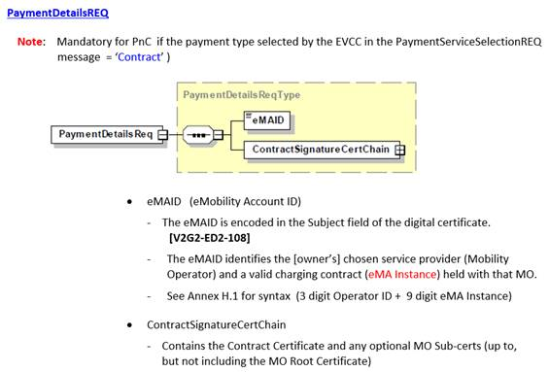
Figure 9: PaymentDetailsREQ message
See the appendix for more information on the public and private keys.

EVSE Authenticates the Contract Certificate
The EVSE will then receive the PaymentDetailsREQ message from the vehicle and authenticate the contract certificate credentials using one of its stored mobility operator root certificates locally. After authenticating, the EVSE will send the eMAID included in the request message to the mobility operator.

Mobility Operator Authorizes eMAID
Once the mobility operator receives the eMAID, it verifies that the eMAID is associated with a charging contract.

Payment
The payment processing will be done by the Monetization Platform. After the mobility operator verifies that there is a charging contract associated with the vehicle, the MO will send the contract information to the Monetization Platform. The mobility operator then sends a response to the charge station, and charging begins.

User Notification
When charge start is successful, the user will receive a notification in FordPass indicating that charging has begun. This is a previously existing notification.
All In-Vehicle HMI Plug and Charge Notifications are 8-second auto-dismiss messages (no sound alert)
FordPass and SYNC/HMI teams will provide detailed specifications on user notification.

Sending Charge Station Information to the Cloud
If available, the EVSE ID will be delivered from the OBCC to the Cloud when the user plugs into a digital charging station regardless of whether Plug & Charge is enabled. If it is not available, 0 will be sent instead. Additionally, the communication type (TLS or not) and station type (ISO or non ISO) will be sent to the cloud.
The GPS location of the charging station will come from the charging location and be sent from the vehicle to the Cloud; this is existing functionality.
The EVSE ID will be collected for the following purposes:
- EVSE ID will be collected to support customer service analytics for the Ford charging service including the following:
  - Identification of specific chargers prone to failures so that defective chargers can be reported to charging network partners
  - Measure opportunity for future expansion to Plug & Charge feature using automatic activation of chargers by communicating EVSE ID to charging network partners.
    - Specifically, Ford will monitor usage of EVSEs which do not support ISO 15118-2 Plug & Charge but do report an EVSE ID to the vehicle

2) EVSE ID may also be reported to customer as part of the charging invoice and stored as long as the charging invoice is available.

Charge Begin is Unsuccessful
After the user plugs in the vehicle, if charging does not immediately begin, the user will receive a notification on FordPass and in the vehicle HMI if the vehicle is powered on. Plug & Charge will also temporarily be disabled until the next time the vehicle is moved; in this case, the user will not be notified in the change of PnC status. See below for list of possible errors.

Every user authorized to the account will receive the following notifications in FordPass:

Reason for Error | Auth. Types | Region (NA/EU/Both) | In Vehicle status/notification (center stack HMI) | FordPass Notification | Copy
ISO, out of network station | P&C | Both | Message displayed  (Show only when the Feature is Enabled in the Vehicle) | Notification sent to FP | This charging station is out of the Ford network. To charge here, please plug in again and follow the instructions on the station.
Non-ISO, out of network station | App, RFID | Both | No In-Vehicle Notification | Notification sent to FP | This charging station is out of the Ford network. To charge here, please follow instructions on the station.
Non-ISO station, in network station | P&C | EU | No In-Vehicle Notification | Notification sent to FP | To charge here, please use the FordPass app or your RFID card.
Non-ISO station, in network station | P&C | NA | No In-Vehicle Notification | Notification sent to FP | To charge here, please use the FordPass app.
Backend system failures | P&C, App, RFID | EU | Error message displayed on screen | Notification sent to FP | Something went wrong. To charge here, please plug in again and use the FordPass app or your RFID card. If this continues, follow the instructions on the station to start charging.
Backend system failures | P&C, App | NA | Error message displayed on screen | Notification sent to FP | Something went wrong. To charge here, please plug in again and use the FordPass app. If this continues, follow the instructions on the station to start charging.
EVSE or vehicle failure in authorization process (e.g. certificate rejected by EVSE) | P&C | EU | Error message displayed on screen telling user to use other means to authenticate | Notification sent to FP | Something went wrong. To charge here, please plug in again and use the FordPass app or your RFID card.
EVSE or vehicle failure in authorization process (e.g. certificate rejected by EVSE) | P&C | NA | Error message displayed on screen telling user to use other means to authenticate | Notification sent to FP | Something went wrong. To charge here, please plug in again and use the FordPass app.

Because the vehicle needs to be powered on in order for the user to see the notifications, if the user is able to resolve the issue before seeing the notification, the HMI notification will be cleared to avoid showing messages that are no longer relevant.

Plug & Charge Off
When Plug & Charge is off, the user will not have this seamless charging experience when plugging in. The Locate and Pay requirements documents detail the charging experience when PnC is off.

Charging in Progress
When charging has successfully begun, status information will be displayed in vehicle and can be tracked in FordPass.

Status
The user can track the charging status via FordPass and in vehicle.

FordPass Status
The user can check the FordPass app to the monitor the status of the vehicle. This is detailed in the EV Features FB5 PRD.

In-Vehicle Status
The user will be able to track the charging progress in vehicle. Because this status is applicable to more than one feature, the status details will be provided in an external document by Team Edison.

Charging Complete
When the user unplugs, the following will occur:
- User receives notification/status in vehicle
- User receives notification via FordPass
- Trip & Charge Log is updated

In-Vehicle
When charging is complete, in vehicle, the following will be displayed:
- SOC
- Total cost
- Total time plugged in
- Total distance added
- Balance on subscription, if user has subscription (kWh remaining or stored value monetary value)
If the payment information is not available at vehicle key-on, Total Cost and Balance on Subscription will be displayed as “Not yet available.”
A note will be included at the end of the receipt if the charging session cost information is not available: “Charging cost and updated balance information will generally be available in FordPass within 24 hours after the charging event.”

FordPass Notification
The user will receive a notification indicating the charging information after the charge is complete. This will include the following:
- Total cost
- Balance on subscription, if user has subscription
All users will receive a charge summary notification any time a charge event involved with CMS.

Trip & Charge Log Updated
There will already be a charge event added to the Trip & Charge log. As a part of this feature, when a user utilizes Plug & Charge, the following will also be displayed in the log:
- Total cost of charging
- Total distance added
- Balance on subscription if user has subscription (one-time only)
- Total time plugged in
All charge events that involve the CMS will include the total cost of charging and/or balance on subscription, depending on subscription rules. All charge events will include the total distance added and total time plugged in.
FordPass and SYNC/HMI will provide detailed specifications on user notification.

Disabling Plug & Charge
If the user decides to disable Plug & Charge via FordPass, the following will occur:
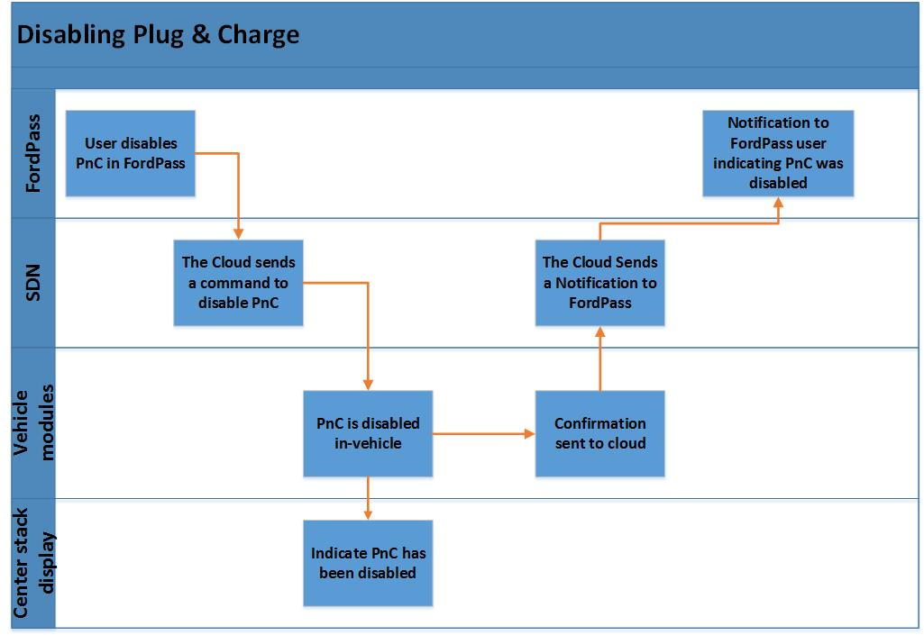
Figure 11: Plug and Charge Disabled Process

Only Subscription authorized user can disable the feature via FordPass and all authorized users will receive related notifications. Contract certificates will not be affected when Plug & Charge is disabled, so that enabling Plug and Charge soon after would be a simple and seamless experience.
If cloud does not receive PnC disable alert within 20 seconds of disabling PnC, user needs to be notified via FordPass that feature was not disabled.
Customer messaging details will be specified in FordPass design requirements.

Re-Enabling Plug & Charge
If the user decides to re-enable Plug & Charge (after the first time it was enabled) via FordPass, the following will occur:

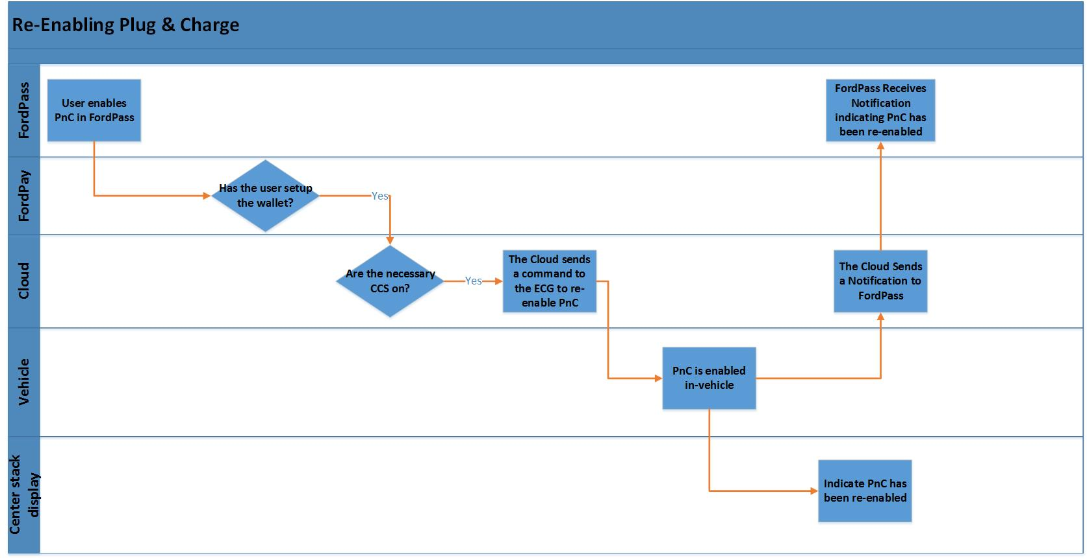
Figure 10: Re-Enabling PnC

Any authorized user can re-enable via FordPass and all authorized users will receive related notifications.
Customer messaging details will be specified in FordPass design requirements.

Managing Expired Contract Certificates
As explained in section 6.6, contract certificates will be installed in the vehicle when the user first enables Plug & Charge. These certificates will allow the backend systems to make a connection between the user and their subscription/payment method.

Success
Once installed in the vehicle, the maximum length of time contract certificates can be valid for is 2 years, according to the ISO standard. The cloud will store and track the expiration date of the contract certificate. One month before the contract certificate expires, the cloud will initiate a command to install new certificates and delete the expired ones.
If successful, the user is not notified, as this is a background process.

Failure
If the contract certificate deletion and installation is not successful, given that the vehicle still has connectivity, the following will occur:
  - If unable to update contract certs before the expiration date, Cloud will retry until successful
  - If unable to update contract certs after expiration date, assuming cloud connectivity:
    - Notify customer to go to the shop in FordPass
    - Disable PnC

Master Reset/‘Brand’ Connect Reset/Last User Removal
In case of Master Reset, Brand Reset, or Last User Removal signal received by the vehicle, Plug & Charge will be reset on-board and off-board.
The following will occur when user Master Resets:
- Contract Certificates shall delete from the vehicle and Plug & Charge is disabled from the vehicle side (in the OBCC)
- Plug & Charge is disabled in the backend
- V2G shall not delete on OBCC upon any reset
The Master Reset, Brand Connect Reset, and Last User Removal flows are shown below
Figure 11: Master Reset Flow
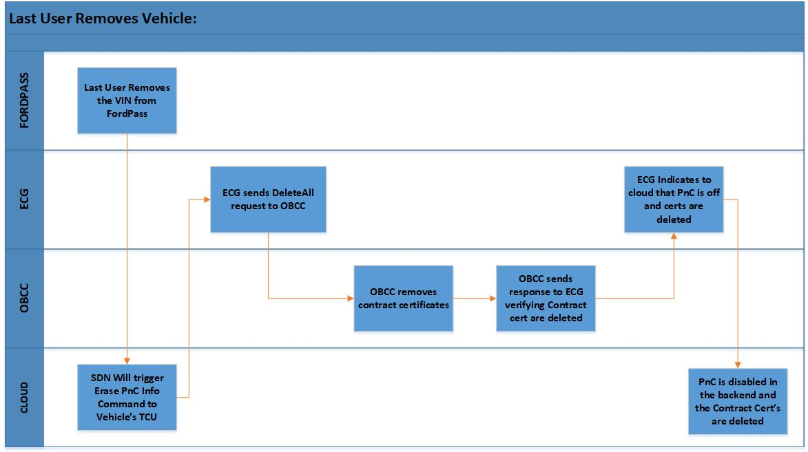
Figure 12: Last User Removes VIN

Master Reset recovery is not in scope for Plug & Charge features. No information will be kept in the vehicle after any of the resets.

OBCC Swap
If the OBCC is damaged and needs to be replaced, an OBCC Swap will take place. The Peripheral Provisioning SPSS details module swap requirements.

Once the module is replaced and the Cloud is alerted that it has been swapped, the Cloud will void old contract certificates and reinstall new ones in the new OBCC.

Subscription Rules
When the backend (CVPODS) receives a “un-enrollment request” from the Monetization Platform (MP), the certificates will be deleted from the vehicle. Below are the subscription rules for Plug & Charge:
When:
- The subscription owner is removed
  - Then SSP sends CVFMA request for un-enrollment, CVFMA sends request to CVPODS for un-enrollment
- The subscription owner cancels subscription
  - Then SSP sends CVFMA request for un-enrollment, CVFMA sends request to CVPODS for un-enrollment
- A user free trial ends
  - Then SSP sends CVFMA request for un-enrollment, CVFMA sends request to CVPODS for un-enrollment
- Ford can’t collect payment
  - Then SSP sends CVFMA request for un-enrollment, CVFMA sends request to CVPODS for un-enrollment

RFID Card – EU Only
In the EU, the user can start charging using an RFID card in addition to Plug & Charge. Due to the RFID card and the certificates being linked to the same customer account in the CMS/Mobility Operator, if the user loses the RFID card, new certificates need to be created and sent to the vehicle.

Charging Ecosystem
Below is an overview of all the 3rd parties involved in the Plug and Charge charging ecosystem.

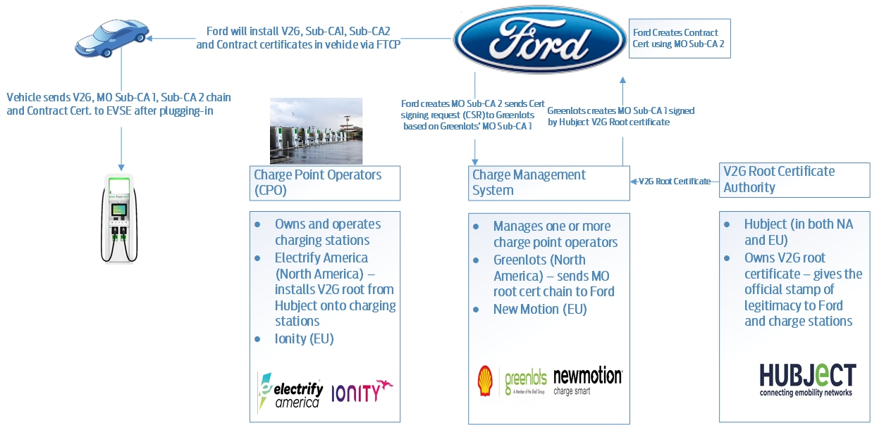

Figure 14: PnC Charging Eco-System

Choosing Contract Certificates Based on Domain component Data Field in EVSE Leaf Certificates (SECC Certificate)
- When the user plug-in at EVSE, EVSE sends leaf certificate to OBCC that used in the TLS layer and OBCC Authenticates the EVSE leaf Certificate with V2G root certificates that stored in the OBCC module.
- Ford CMS partners will work with Charge Point Operators (CPOs) to set the Domain Component field value of the EVSE Leaf Certificates to reflect the identity of the CPO or CMS operator (e.g., GRL – Greenlots; NMO - New Motion; CPO – Electrify America, etc.) While establishing TLS, the OBCC will read the Domain Component of the EVSE Leaf Certificate and use this information to determine which Charging Contract Certificate/eMAID (and associated Sub-CA certificate chain) to send to the EVSE in the ISO 15118-2 “PaymentDetailsReq” message.
- If Domain component is “CPO” as default in leaf Certificate, then OBCC send certificate based on the certificate priority.
- Cloud (IVSS) will Populate Domain component data field in the contract certificates while creating the certificates that will be received from PAAK FI and PAAK FI will receive from EVSS (PAAK FIEVSSPAAK FIIVSS).

V2G Certificate Delivery Upon OBCC Provisioned at EOL
- When Vehicle is in Factory / Transport Mode and OBCC module gets provisioned at the End of the line, a cloud shall orchestrate V2G certificate payload to OBCC via ECG even before the customer authorized to the vehicle and customer never complete the subscription process.
- PnC ECG Application shall initialize and run in Factory and Transport Mode.
- PnC ECG Application shall shutdown when the vehicle is in Normal mode and Un-authorized.
Figure 15: V2G Certificate Delivery

V2G Certificate Delivery Upon FordPass app Authorization
- Upon Modem Authorization, CVPODS will receive EV2G Enrollment record from CVFMA and deliver V2G root certificate to the vehicle, if Active state for V2G Root certificates are not found.
- EV2G_PK00200 New feature package being developed to facilitate enrollment

V2G Certificates Retry Mechanism
CVPODS shall Re-trigger the V2G Certificate payload up to 5 retry attempts, when V2G certificates are failed to install in the OBCC module.
MotiveModeBegin alert from the vehicle is the trigger for the CVPODS to retry the V2G Certificates.
The Process Shall work as follows:
Start:
- When CVPODS received OBCC Provisioning and EV2G Enrollment, then CVPODS will register the VIN with VSDN/Routing Services for event- MotiveModeBegin.
Listen:
- CVPODS shall listens to Routing topic for MotiveModeBegin alert.
- Each MotiveModeBegin event received to CVPODS, it shall Check to see if V2G Certificates are Active, if Not, CVPODS shall do the retry and increment retry counter to +1
Stop:
- CVPODS shall unsubscribe the VIN from Event Hub for MotiveModeBegin alert when V2G Certificates are Successfully delivered to the vehicle.
- Or, have reached a maximum retry attempts up to 5.

EOL Config for Each Vehicle Life Cycle Modes
The following are the EOL DID configurations for NA and EU region on each vehicle life cycle modes:
- Factory and Transport
- CCS Vehicle connectivity, Vehicle data, Vehicle location, and Driving characteristics will always be enabled
- DE17 bSAllow_FEATURE27_PlugandChargeEV = ON
- DE1A bPAllow_FEATURE27_PlugandChargeEV = ON
- CCS Policy file UAllow = ON
- Normal mode without Authorization – Location sharing is disabled by default
- CCS Vehicle connectivity, Vehicle data will always be enabled, and Vehicle Location is disabled by default
- DE17 bSAllow_FEATURE27_PlugandChargeEV = ON
- DE1A bPAllow_FEATURE27_PlugandChargeEV = ON
- CCS Policy file UAllow = OFF
- Normal mode with Authorization
  - All CCS settings are enabled by default
  - DE17 bSAllow_FEATURE27_PlugandChargeEV = ON
  - DE1A bPAllow_FEATURE27_PlugandChargeEV = ON
  - CCS Policy file UAllow = ON

Report all the Installed Certificates Status to CVBOP
- Certificate Status command type shall report the V2G and Contract certificate status to the cloud that was installed in the OBCC module.
- Certificate Status Command shall trigger from CVBOP triage portal to the vehicle regardless of the ignition status.
- Tester/Feature owner can see how many certificates are installed in the OBCC module to triage the issue.
Command Type Request:
0x7 - Certificate Status
Payload:
- 0x00 --> not requested
- 0x01 --> requested

Response
- Number of Installed V2G Certificates
- List of Installed V2G Certificate ID
- Number of Installed Contract Certificates
- List of Installed Contract Certificate ID

Fleet Requirements
- Ford Commercial Solutions (FCS) shall provide an option to Toggle ON the PnC Feature to Install V2G and Contract Certificates in the OBCC module that are required for Public Charging.
- FCS shall Provide an option to Toggle OFF the PnC feature in the Vehicle’s OBCC module.
- CVPODS shall provide the following status updates to FCS upon any change in a certificate state:
  - Toggle Request has been "Acknowledged"
  - The Toggle Request has been submitted for retry
  - Toggle ON request with Deliver the Certificates has succeeded.
  - Toggle ON request with Deliver the Certificates has failed (post 3 day retry strategy)
  - Certificate renewal has been submitted (certificate is pending expiration and an update is required)
  - Toggle OFF is succeeded.
  - Toggle OFF is Failed.
- Authentication - Transition to AD token authentication, App to App authentication with FCS shall requires using one set of credentials not tied to a specific customer
- CVPODS shall do the following and allow FCS to update on a customer's behalf. Therefore, the current one to one relationship that is in production is not applicable for FCS
  - Customer ID to be persisted
  - Customer type needs to be set as a fleet
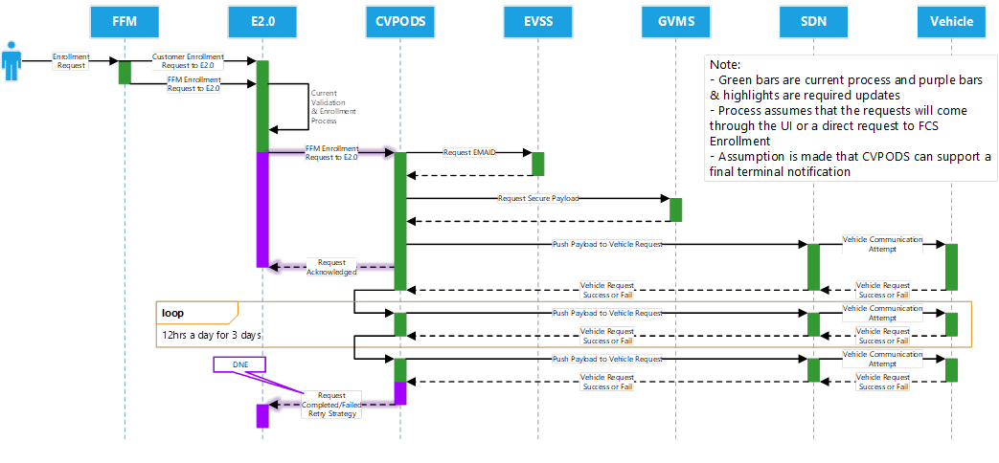

Appendix
Definitions, Acronyms, and Abbreviations
Define all terms, acronyms, and abbreviations used in this document.

Acronym | Description/Definition
APIM | Accessory Protocol Interface Module also called SYNC; head unit of the vehicle
BEV | Battery Electric Vehicle
BCM | Body Control Module
BCCM | Battery Charge Control Module
CCS | Customer Connectivity Settings
ECG | Enhanced Central Gateway
EVCS | Electric Vehicle Connected Services
FB5 | Feature Bundle 5: The release of telematics features by Ford Motor Company that will include the updated functionality described in this document.
HMI | Human Machine Interface
HPCM | Hybrid Powertrain Control Module
OBCC | Off-board Charge Control
POI | Point of Interest
PHEV | Plug-in Hybrid Electric Vehicle
Public key | Public Key are made available to everyone in on-line directories and repositories. Public keys can also be encapsulated in a digital Certificate. A message Encrypted with a Public Key can only be decrypted using the Private Key.
Private key | Private keys are kept secret and intended to be held only by the owner of the Public key. A message Encrypted with a private key can only be decrypted using the corresponding Public key. This operation is the basis for the Digital Communication.
TCU | Telematics Control Unit
VIN | Vehicle Identification Number
V-SDN | Vehicle Service Delivery Network

Additional Certificate Handling Details

Certificate Handling
The plug and charge mechanism defined in the ISO 15118 standard enables an automatic authentication, authorization, and billing procedure during the charging process of an electric vehicle. ISO 15118 is a protocol that specifies a digital communication structure among vehicle, EVSE, and secondary actors and enables Plug and Charge feature.
As a part of this process, many certificates need to be securely exchanged to ensure the vehicle is authorized to charge at that station and payment can happen in the backend.

Here are the Primary Actors and Secondary Actors are involved in this process:
Primary Actors Secondary Actors
- EV 1. Mobility Operator
- EVSE 2. Charge Point Operator
- User 3. Energy Provider
4. Distribution System Operator
5. OEM Backend

Certificate Handling Actors
The main actors that in the certificate handling process that will be discussed in this document are the Charge Point Operator and the Mobility Operator.

Charge Point Operator (CPO)
The Charge Point Operator is involved with the following:
- Operates and maintains charging station (EVSEs)
- Purchases electricity from a Utility or 3rd party supplier
- In some instances, an electric utility may operate charging stations as the CPO and supply electricity
- Provides a dedicated communication network and IT backend operation serving customers and station owners/operators

Charge point station owner/operators must use the charge point network and IT backend for Authentication and Authorization
The general flow of communication between the V2G Root Certificate Authority and the EVSE is shown below.

Certificate transfer between Charge Point Operator and EVSE

Mobility Operator (MO)
The mobility operator is the Entity with which the customer has a contract for all services related to the EV operation. It is involved with the following:
- Holding the charging service contract with the driver (driver typically have contracts with multiple MOs and CPOs)
- Authenticating users, authorizing transactions and controlling certain EVSE functionality
- Providing live data of locate and reserve stations and payments etc.
The general flow of communication between the mobility operator and the vehicle is shown below.

Certificate transfer between Mobility Operator and Vehicle

Role of External IT backend Operation
The Communication protocol for Authentication and Authorization between EVSE and IT backend can be proprietary and open charge point protocol.

Authentication
Authentication done by the IT backend allows the vehicle to be identified. It establishes validity of the credential presented at the charging station.

Authorization
During the authorization process, the IT backend will get the amount from the subscriber, check the existing account for sufficient funds, and charge the user account or credit/debit card. At this time the charging station will allow energy to flow to the vehicle.

Provisioning Certificate Procedure
Installing a contract certificate into the EV should be done in an automatic way, as already discussed, in order to reduce overhead and costs for the customer. This procedure is called certificate provisioning. With help of certificateinstallationReq message the certificate contract can be transmitted from the secondary actor i.e. mobility operator to the vehicle for installation.

